**OUTPUT SCREENSHOTS**

**CODING SCREENSHOT:**

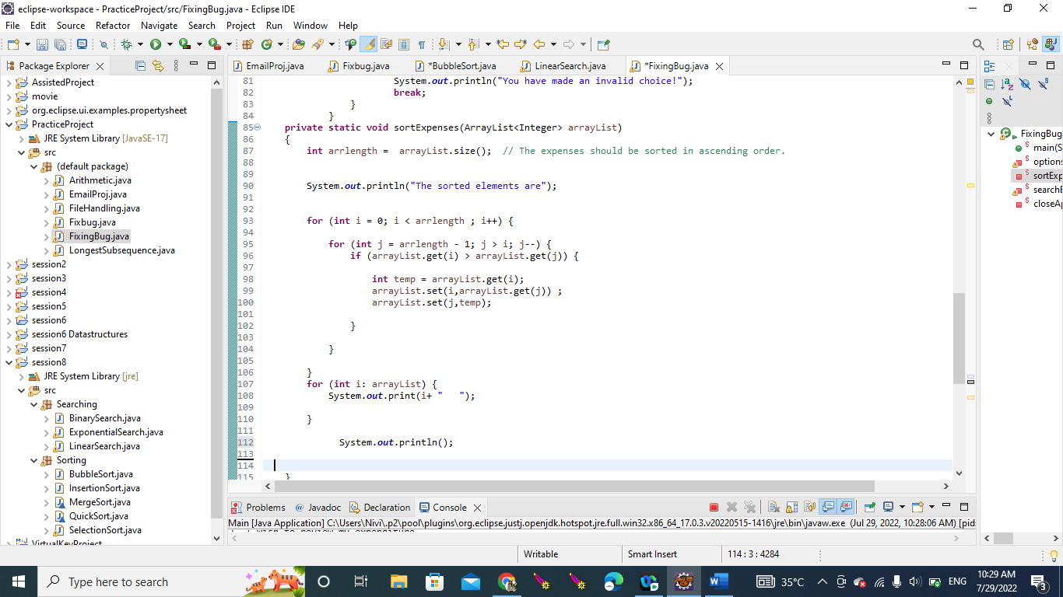

**OUTPUT SCREENSHOT:**

1. **REVIEW MY EXPENDITURE**

1. **ADD MY EXPENDITURE:**

1. **DELETE EXPENDITURE:**

1. **SORT THE EXPENDITURE:**

1. **SEARCH THE EXPENDITURE:**

1. **CLOSE THE APPLICATION:**

